Adam Dziacky

40492256

4.3.2022

Report

Web-Technologies Trimester 2 Assessment

Contents

Introduction 2

Part 1 – Description of the quiz and a sample question 2

Sample Question 2

Part 2 – Summary of background research, potential solutions (libraries, APIs…) 2

Part 3 - Features and possible extensions 4

Possible extensions 4

Part 4 – Site organisation and navigation tree diagram 4

Navigation Tree diagram 4

Upper menu 5

Part 5 – A sketch of an initial user interface and motivation for my design 7

Colour Palette 7

Logo 8

Part 6 – Additional sections – Features, data storing 8

Leader Board 8

Database 8

Audio 9

Timer 9

Conclusion 9

## Introduction

Quiz websites are a great way to learn something and entertain yourself at the same time. It can enhance the learning process. It also helps you to remember the information you just learned. I believe that’s a great reason we get to create a website like that for this assessment.

This report contains plans and ideas for creating quiz website which is the second part of the assessment. I discuss and describe the background research, design, features and structure of the website and give motives on why I decided to use certain technologies and approach.

## Part 1 – Description of the quiz and a sample question

**Do you consider yourself a movie addict / maniac / enthusiast? Many people do but not many of them really are. This is your chance to prove yourself worthy of that nickname. Ahead of you is the series of 10 questions featuring some of most famous movies of all times. The sooner you answer, the more points you get. Are you ready?**

This website / quiz is all about the movies. Honestly, I don’t know a person who doesn’t love them. Many people think they are true movie enthusiast but not many of them really are. People can get really excited and passionate about the movies they like. They would even argue which movies are the best, who is a bigger fan. Well, there is a quite easy way to determine this and finally end all the quarrels among movie fans. Test yourself and share your results with your friends!

This quiz will consist of 10 questions, each one about a movie that belongs to some of the greatest movies (according to the author). These questions will be of multiple types, such as multiple choice, fill in the word, recognize a scene etc. To make this even more exciting, the questions will be getting harder and harder. The sooner you answer, the more points you get. Are you ready?

Sample Question: Name the movie from this quote: “Snakes. Why’d it have to be snakes?”

Answer: ……………………………

## Part 2 – Summary of background research, potential solutions (libraries, APIs…)

First and foremost, I browsed and inspected several quiz websites to see, what features they include. I made a list of them and will try to implement as many as possible. However, I am a single student with no budget, so I need to know my limitations.

I focused quite a lot on menti.com – which is a website that could be considered as a quiz website. I really like it from the design point of view, and it is also very interesting. It brings a lot of features and nice surprises in comparison with other traditional quiz websites. It feels personal, funny, exciting, appealing. That’s what I would like to aim for.

Things to aim for:

* Interesting design – modern, simple, minimalistic, element of surprise
* Concise questions – to keep the players’ attention, keep him excited
* Personalized experience – use players name / nickname
* Diversity of question types – Multiple choice, fill in the word, recognize the scene / part of soundtrack or dialogue
* Originality – there are thousands of such websites – try to stand out

Apart from features I want to include, my research also helped me to understand what I want differently. Many of the quiz websites have no catching design, no added value, no surprise. Nowadays a very high portion of the users focus heavily on design. If they do not like the website or find it unclear, they will leave immediately. The key is not only to gain the users attention, but also to keep it.

Things to avoid:

* Boring the players
* Bugs
* Not enough clarity in design
* No added value / surprise
* Long waiting time / slow response

From technical point of view, I found that there may be some libraries and tools that might help me a lot. I decided to look more into Bootstrap, which may be very useful when considering designing part of my website. I do not see a reason not to use this modern tool and simplify my work. Moreover, I would like to learn more and use jQuery library for JavaScript. It is supposed to ease working with functions and do more with less code. There are many brighter programmers than I am, so why not use some of the paths they already paved. I am expecting jQuery to help me incorporate more features into my website easily.

From the APIs I am considering GIPHY API – as there are quite famous gifs from certain movies which I could use in questions. Also, who doesn’t love gifs? When you make people laugh with your website, you are on a good way.

However, to be able to show my skills and abilities gained from past weeks, I will incorporate those libraries just as extras, either a separate page or extra features. A person should have a good understanding of foundation first, then use the tools to ease off the work load.

It also looks like the use of database is necessary. To keep the answers to the questions, save players scores and names. There are many options for databases to choose from – SQL, MariaDB, MySQL. It looks like MySQL is one of the most used databases for websites and web application in 2021, so I will probably use this one, despite having no former experience with anything other than MariaDB.

Now that I know roughly what is ahead of me, this research on useful tools and sources will save me a lot of time. The plan is simple – use HTML to create a structure and content. Then CSS to style my website, order the elements, add some colours and layouts. After that, JavaScript should help me with logic and behaviour such as creating navigation menu animation, leader board, assessing the answers provided by user and interacting with MySQL database which will hold the answers, files, scores, names.

## Part 3 - Features and possible extensions

I am not completely sure what things count as features but here is the list of things I would like to include in my website:

* Drop down menu – For navigation between pages. Concise, good looking. Opened after clicking on the icon
* Side bar – showing progress on the questions. Also, to use the space more efficiently
* Different types of questions – To keep the player entertained and to spice things up a little bit. To distinguish my website from hundreds of others.
* Questions will contain pictures and sound elements – This way you can include so many more things into your questions such as parts of dialogue, locations, scenes, characters. Definitely more exciting than just plain text
* Leader board – Keeps track of your top 5 scores
* Timer – Bringing more game-y experience. The score will be calculated depending on how fast player answers the questions. It is necessary to be able to compare ones’ scores to the scores of his/her friends or to share on social media
* Get and display users name – Offers more personalized experience for the player
* Blog – few articles about some of authors favourite movies

### Possible extensions

* Multiplayer – to be able to challenge your friends in real time
* Multiple Quizzes to choose from (different topics)
* Allow users to create their own quizzes
* Assigning random picture to the user – To show on leader board, adds a bit of fun
* Using database to store the results

## Part 4 – Site organisation and navigation tree diagram

### Navigation Tree diagram

This simple diagram shows the planned layout and pages of my website.

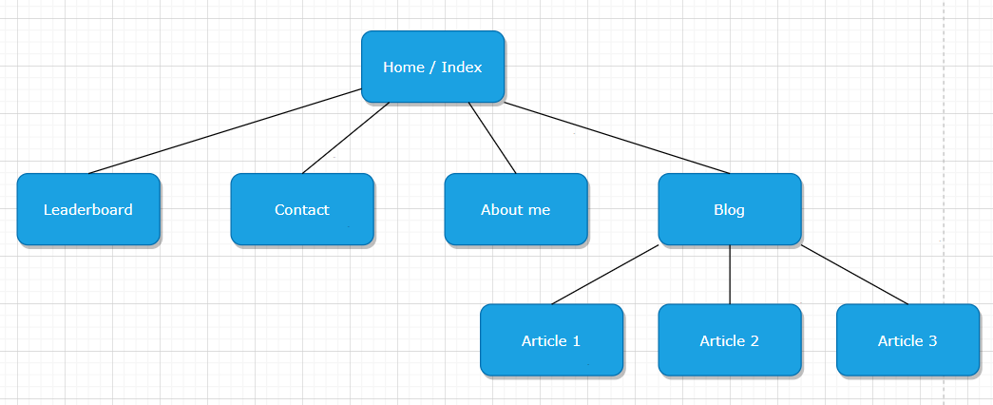

Figure 1: Navigation Tree Diagram

For navigation between these pages, user has an option to choose from upper and lower navigation menu. Both menus will be clearly visible, to make orientation and navigation easy. Rather than having 10-15 pages, I would prefer having fewer and longer to scroll. I believe that for the purpose of my project, 5 pages will be sufficient (+ however many blog articles are available). All the questions and basically whole quiz will be on home / main page – so there is no requirement from user to look for the page where the quiz is.

### Upper menu

This is how I imagine my upper menu to look like. Small clickable icon will expand the menu which is clearly visible. Behind each text is a hidden button, which will darken itself after being pointed on. I was also thinking about using the upper green section which contains the name as a place for a menu which is already expanded. However, I have one website that uses such menu and I had problems with expanding and adding new pages, because there was limited space. Because of that I have decided that dropdown menu is the one I will go with. It saves space, looks good and with simple animation can fit nicely in the modern looking website.

Obrázok, na ktorom je text

Automaticky generovaný popis

Figure 2: Dropdown Menu

Furthermore, it’s one of todays’ standard that search engines favour the websites which include many internal and external links. Because of that, I will also try to include these links inside my text blocks and articles as often as possible. I hold the opinion that today the marketing is a very important part of creating and deploying a website. You need to make your website compelling to the search engines in order to get traffic on your website. Without the traffic and users, there is no point in having a website.

## Obrázok, na ktorom je text Automaticky generovaný popisPart 5 – A sketch of an initial user interface and motivation for my design

Figure 3: User interface

I decided for simple, modern design as many of todays’ websites have. I think people are fed up with overstuffed websites, pictures, ads. I want my design to me simple, clean. There is a header part including the name of the website and navigation menu which will reveal itself after clicking in the icon. Then there is a main section where all the questions will appear. On the side there is a small overview of your progress, which will let you know what question you are currently on. The last part would be a footer with social media icons which act as a link to the profiles on the platform user clicks on. I would also like to add another navigation menu in the footer, so the user doesn’t have to use the upper one after being at the end of the page.

### Colour Palette

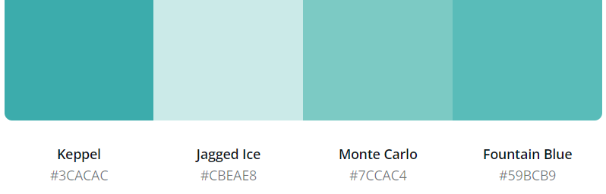 I used Canva to generate is colour palette for me:

Figure 4: Colour Palette

Black writing has very good **contrast** on these colours in the background and it also look very modern. I decided to go with Script MT Bold font, which looks like handwritten. I took this inspiration from sites like Vimeo. Choosing the right script alone can take hours. You must make sure that your font style works well with the rest of your website as well as the content you are providing.

Many of todays’ websites and application provide feature called **Dark mode**. I personally love this feature, as it eases off the workload on my eyes while still providing great contrast. This feature is turned on each one of the applications that I use (as long as it is provided). I would love to try and make one more colour palette for Dark mode if user chooses to switch it. This could be simply achieved by creating a class in HTML, a button and one short function in JavaScript.

### Logo

If I were to design a logo, I would go for something very simple and good looking like this. Many successful websites have very simple logos. Taking the same approach as for the whole website, my first sketch for the logo would look something like this:

## Part 6 – Additional sections – Features, data storing

### Leader Board

I will be trying to implement leader board system for players which will remember 5 top scores. In order to do that, I do not see any other option than using a database to store the results and player names.

To sort, display results and distinguish them by colour I will use JavaScript. Simple array will hold player name, score, and player ID. To sort the array according to the score element, lambda expressions may be helpful. To display gold, silver, and bronze colours I have found that I can use nth-child CSS pseudo-class which matches elements based on their position among a group.

### Database

The part I am most afraid of is to create and connect a MySQL database and make it work together with the website. Few years ago, I had to throw a project away which I have spent months of work on because I was not able to get the database up and running. Hopefully this time it will be different, and I will manage to defeat my nemesis.

### Audio

To be able to use some parts of dialogues or soundtrack for my quiz questions, I will be using simple HTML code. <audio> element can input a small clickable audio track in less than 5 lines. Some things that we fear the most end up being the easiest to implement.

### Timer

There are several ways to create a timer for your website. I think I will make my life easier and will not create a timer from scratch. Many websites will help you design it and provide the code for you to embed into your website. Countingdownto.com is one of them. I still need to use a timer to determine the score for the questions – the faster you answer, the more points you get. For that I will have to use setInterval or setTimeout functions in JavaScript. It would be neat to solve display, nice design and such functionality in one counter. However, to use one to display and the other invisible one for point system seems to me like a good solution as well.

## Conclusion

The main aim for me is to produce something that is working properly and won’t hurt anyone’s eyes. It is very helpful not only to know how to use the modern website making tools and frameworks such as WordPress or Shopify but also to understand the background properly. To be able to know how the fundamentals work and what is behind the scenes of your browser window. This assessment and how it is divided allowed me to do proper research before creating my website, which I appreciate very much. It will be much easier to create a website once you have a plan and know what technologies to use.

I admit that certain sections of this report may have been more detailed. However, I tried to go as deep as my skills and knowledge allowed me at the time. I believe that after reading this report you gained the knowledge of my plans on how my website is going to be created and what technologies it’s going to use.